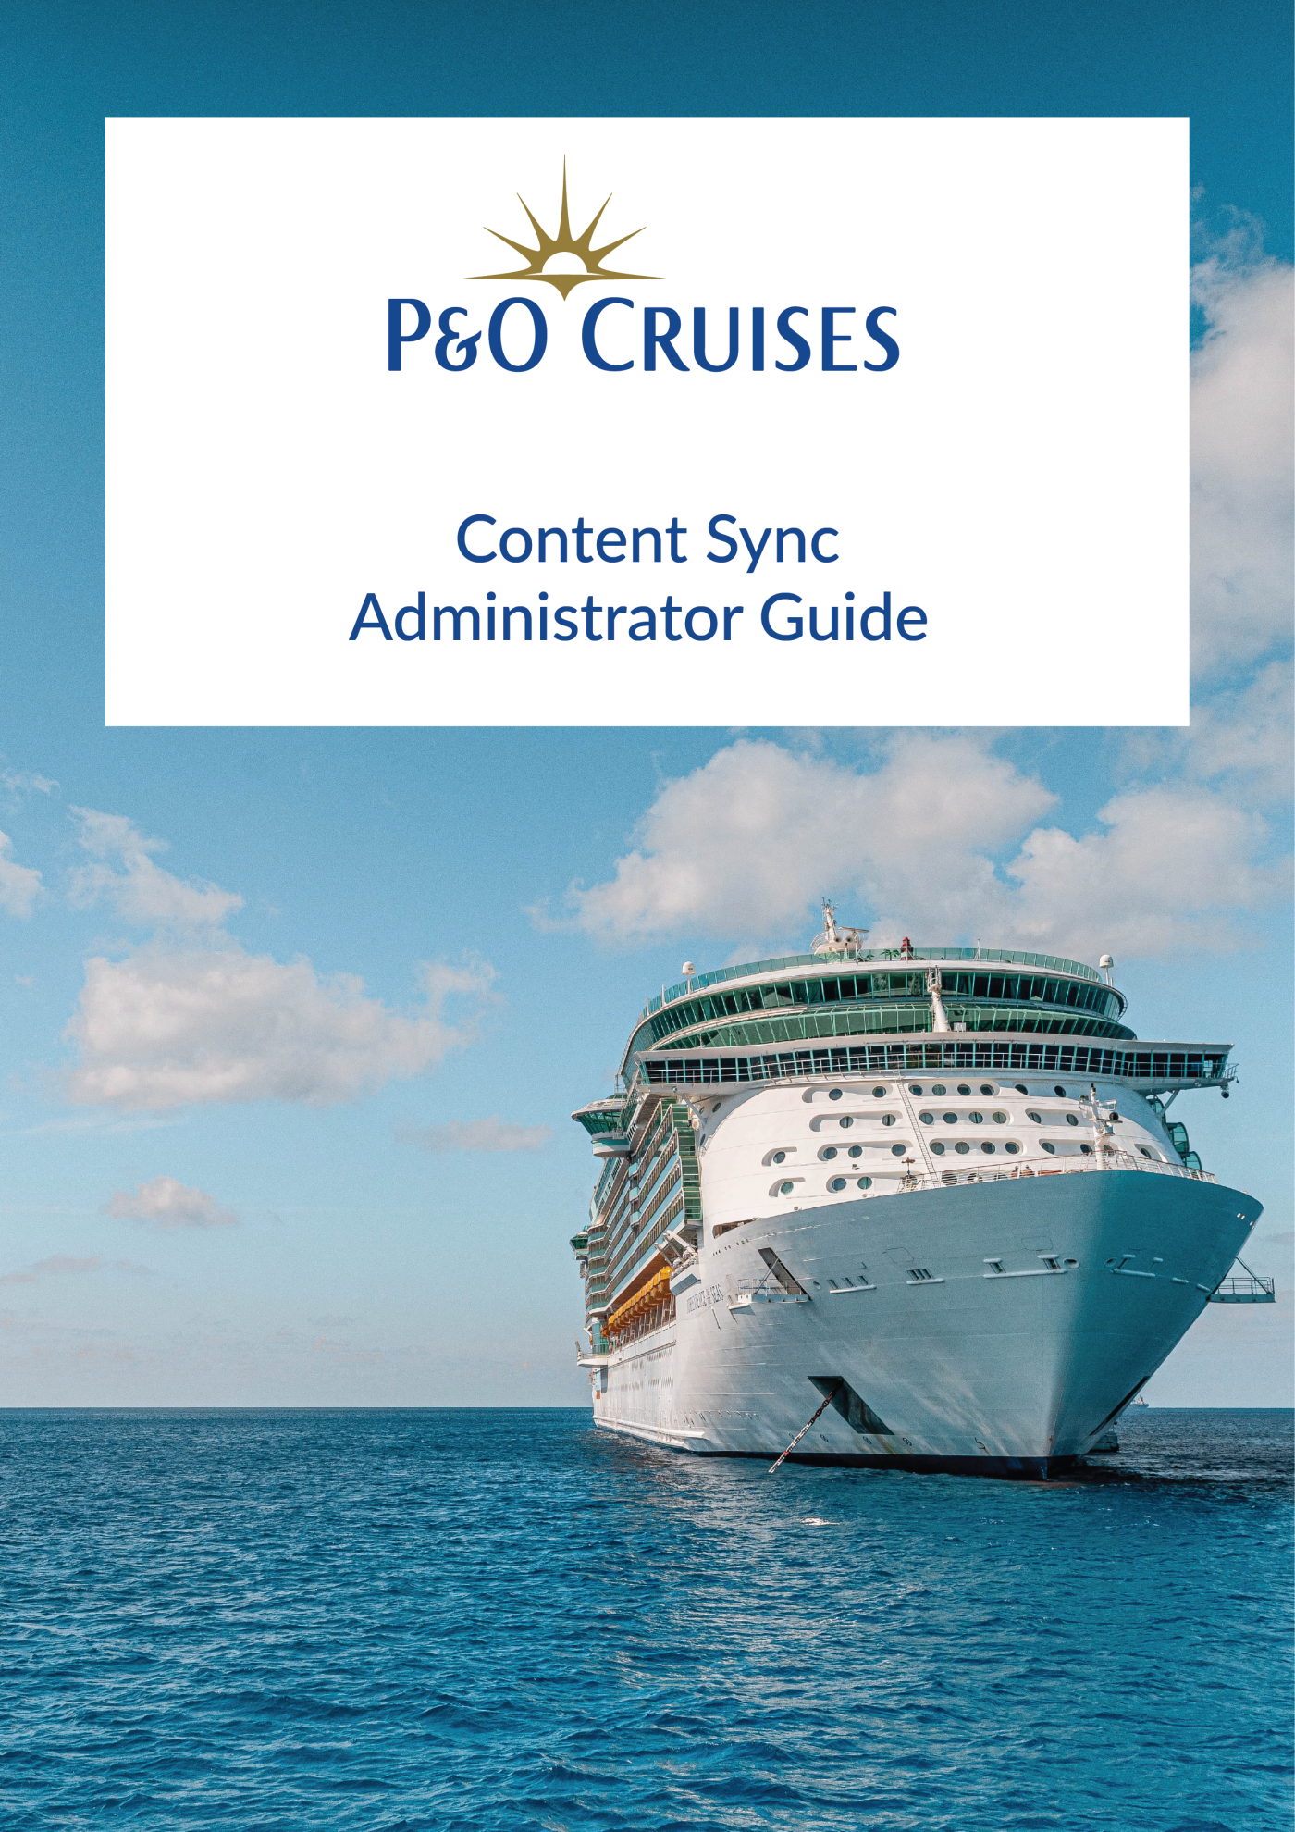

**Content Sync Module**

Shore side application whose main function is to sync text and image content for the Shorex masters currently being authored in Adobe Experience Manager shore side for ingestion by the Kiosk Control Centre on the ship.

All content displayed by the kiosk will be as authored within AEM. The system shall carry out authenticity checks of all content data extracted to avoid the possibility of bogus content being displayed at the kiosks, possibly with malicious intent. The shore excursions content (text, images) displayed by the kiosk service shall be sourced unchanged, which is extracted from the AEM Sync.

Table of Contents

**1. Login Page 4**

**2. AEM Server Settings 5**

**3. API Scheduler 6**

**4. Dashboard 7**

**5. Carousel CMS 9**

**6. Email Distribution List 13**

**7. Users 14**

**8. Reset Password 15**

# 1. Login Page

You can use the Login screen to enter the appropriate email address and password to **login**.

If you forgot your password, enter your email address and use "Forgot **Password?**" link to recover the password.

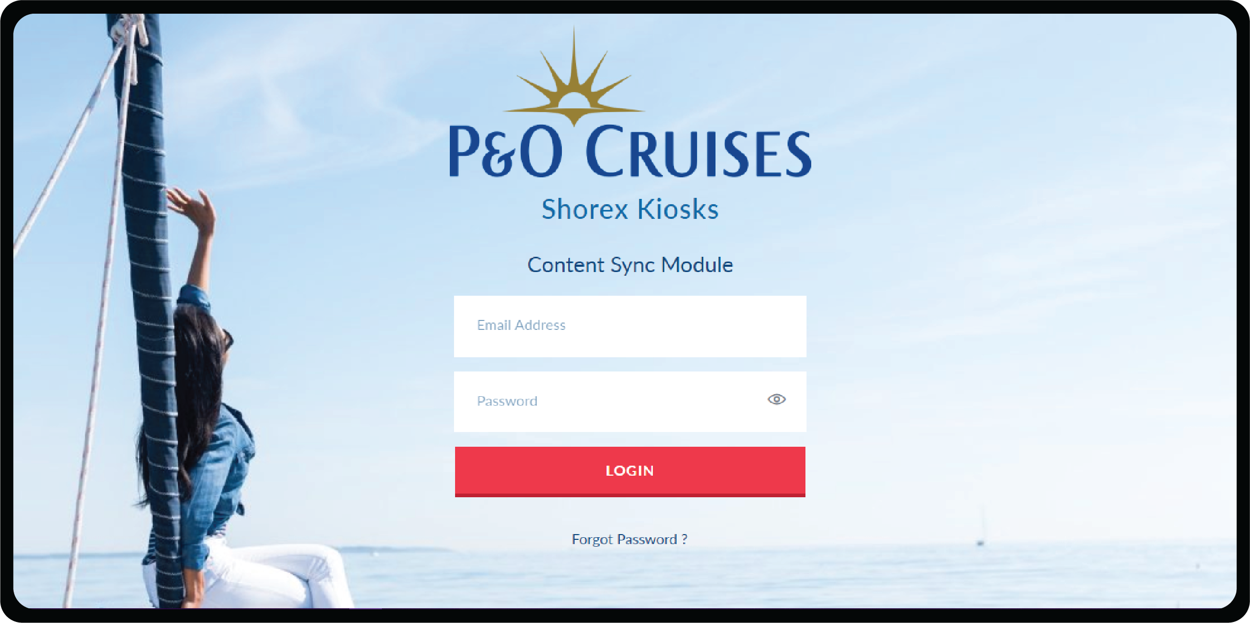

# 2. AEM Server Settings

You can use this page to enter the AEM Server URLs for the data extraction.

You can use **Edit** button to enter JSON Rest API in Excursion data end-point, CDN URL in Domain for digital asset end-point, JSON Rest API (in port details end-point).

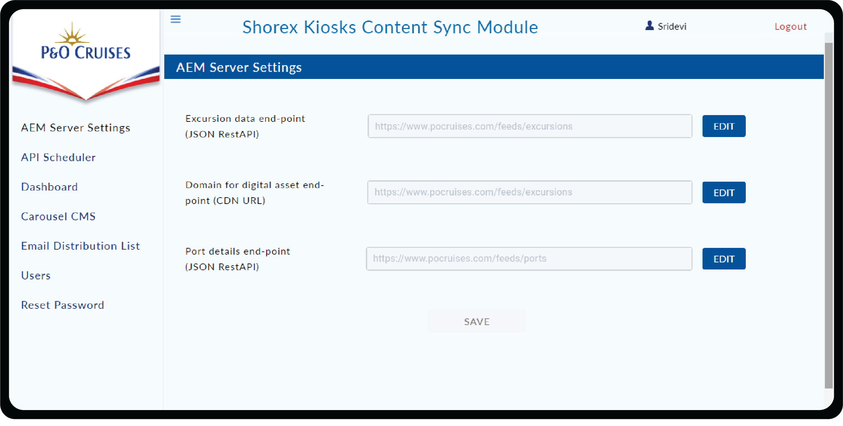

As part of Edit, you can use **Test** Connection to confirm the Status of each of the URLs. **User Name** and **Password** are optional to test the connection. Upon confirmation **save** the URL details for extraction.

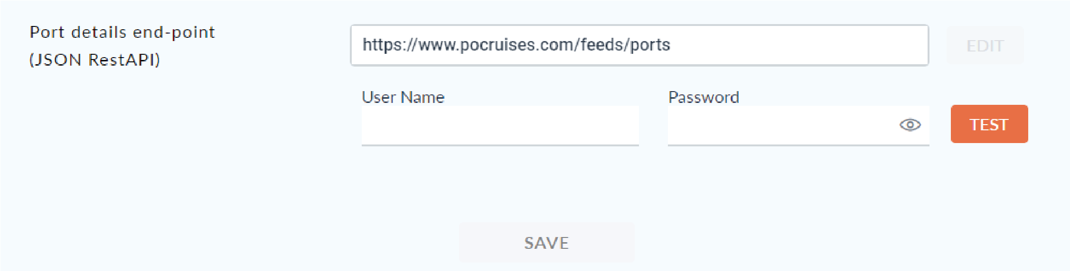

# 3. API Scheduler

This page helps in scheduling the extraction Process from AEM.

You can choose either **Daily or Weekly schedule** for extraction. Also you can choose the time of the day for the respective schedules.

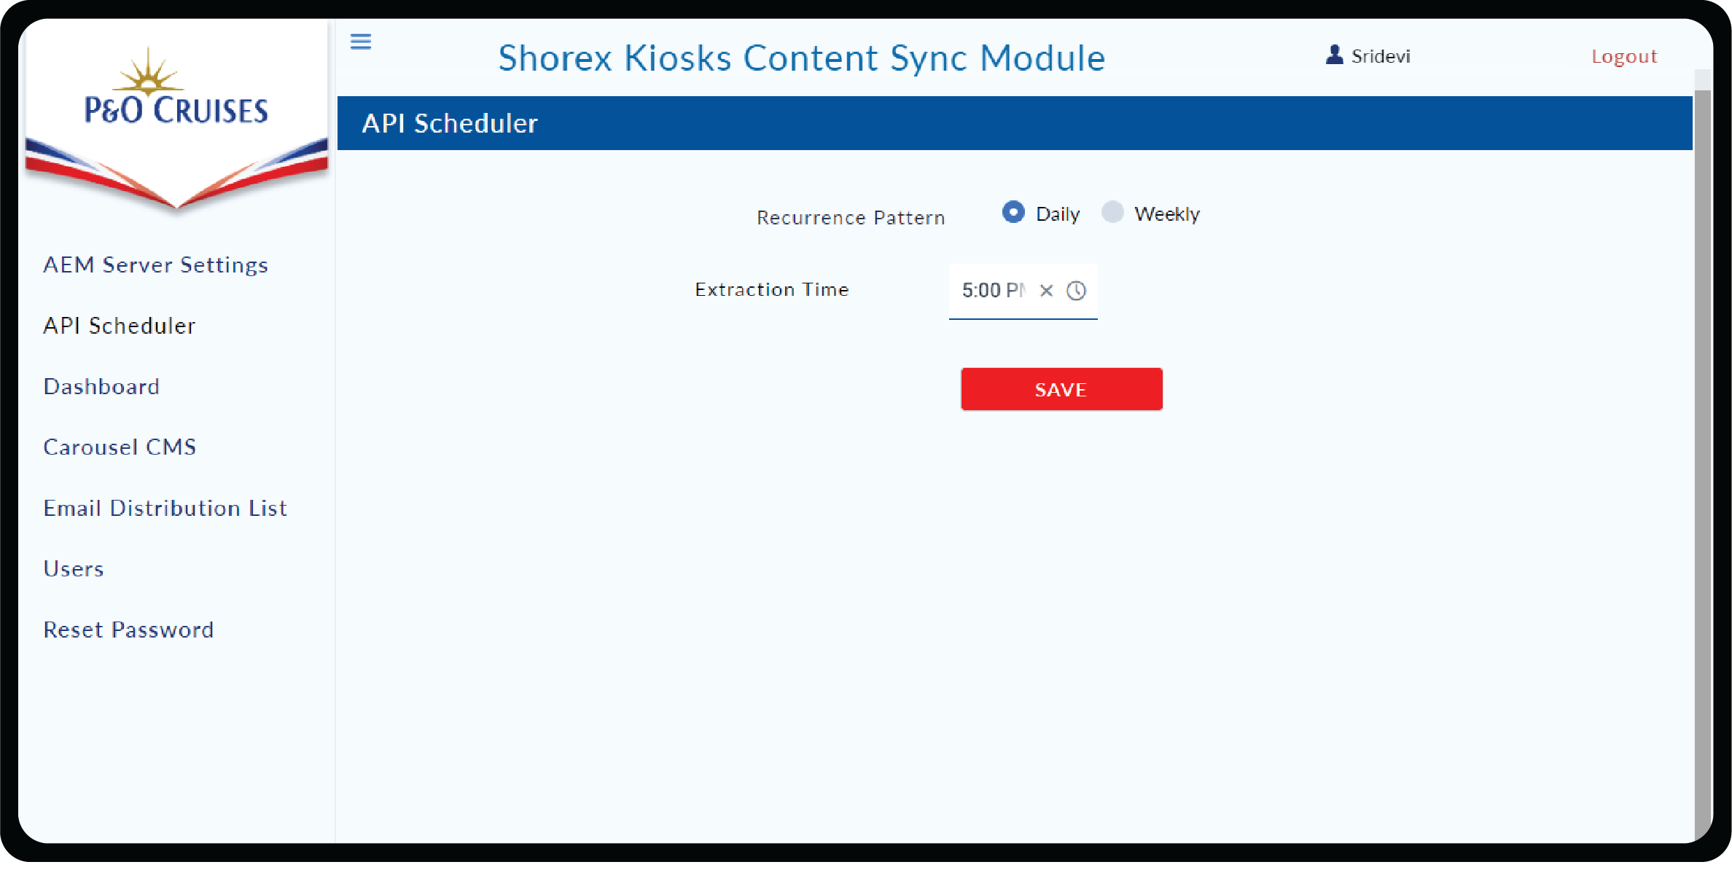

In case you choose weekly, you can choose the day of the week from the **drop down.**

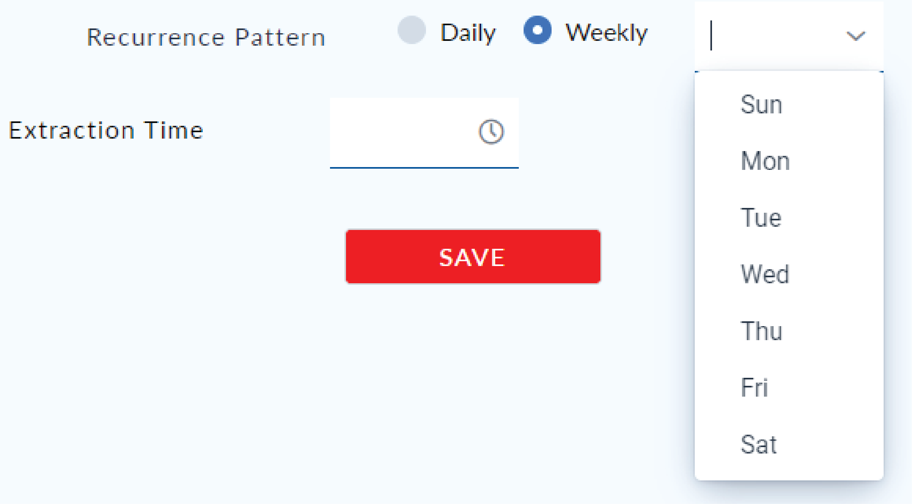

# 4. Dashboard

The dashboard section has the details on Content extraction History.

You can perform the following actions on this Page.

**Perform On Demand Download:** The On Demand Download can be used to perform Asset extraction on a need basis.

**Asset Download:** Asset Download can be used to download the asset of a particular extraction.

**Content Download:** Content Download can be used to download the content of a particular extraction.

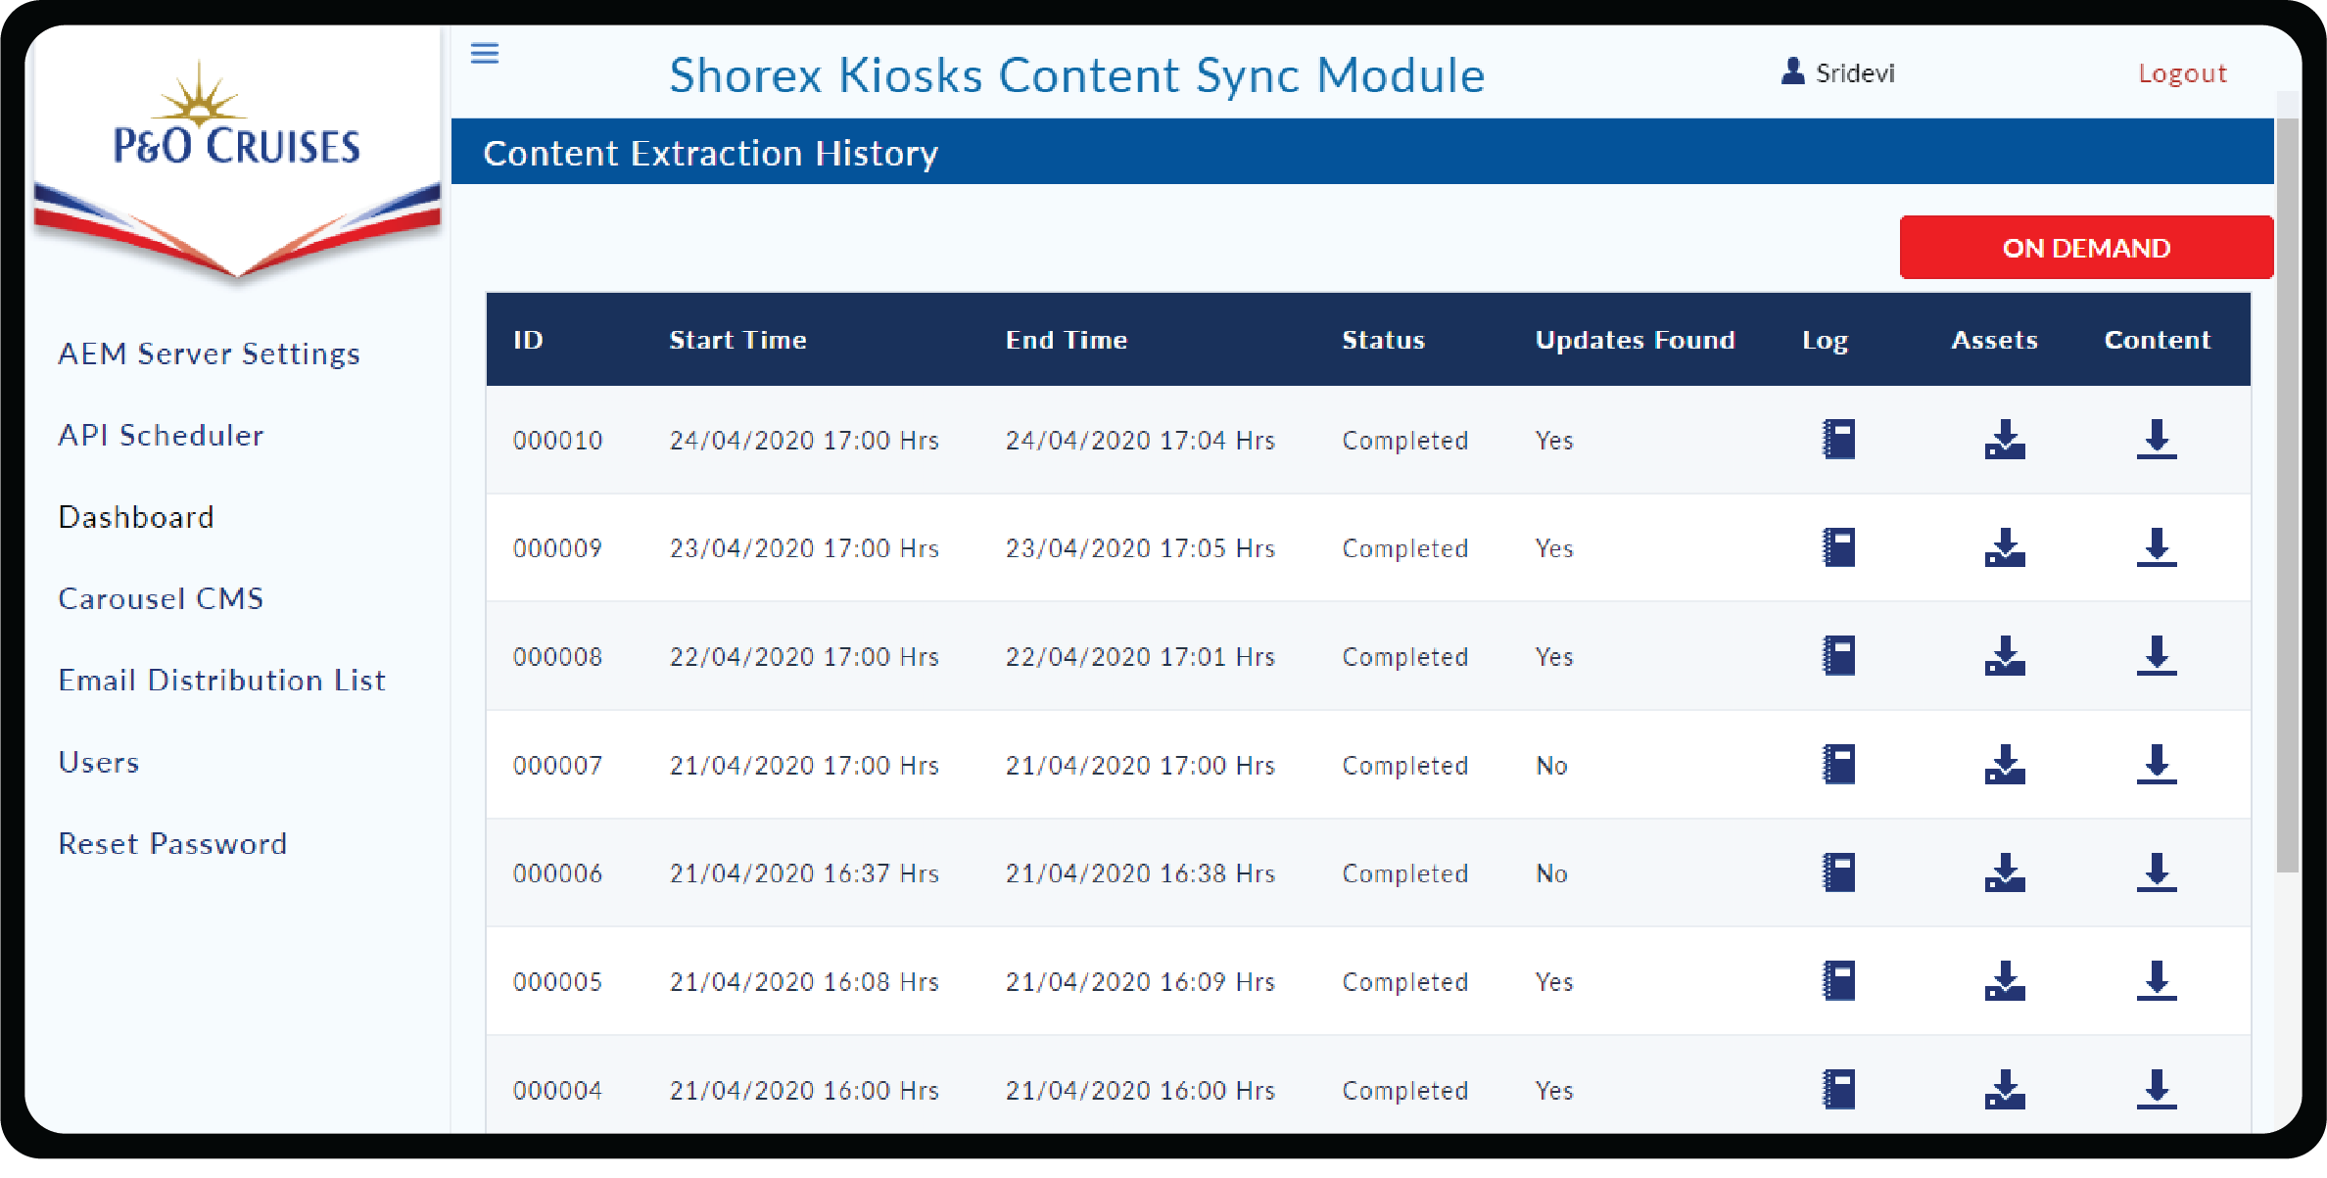

**View Log:** View Log can be used to view the attribute changes for each of the excursion for a particular extraction history.

Check the tick box to get the tour details which has missing data.

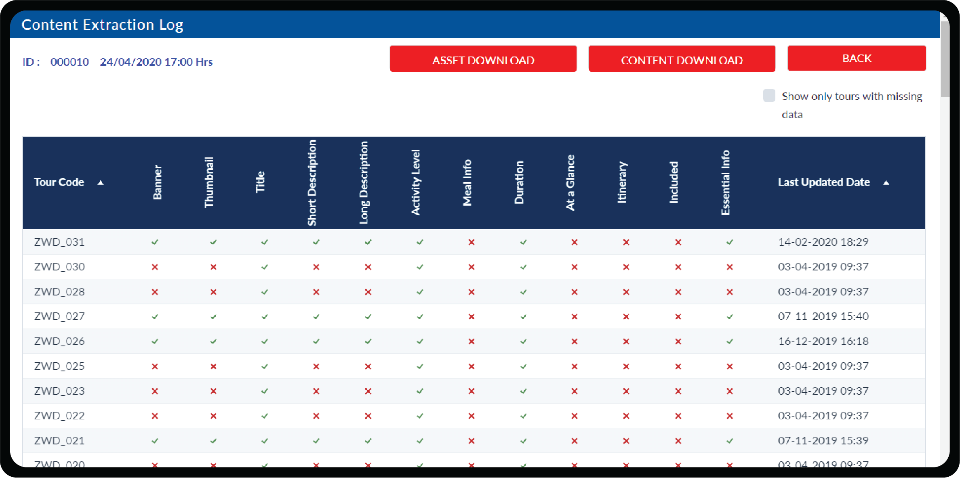

# 

# 5. Carousel CMS

This page is for managing the Carousel Images and Banner Images.

Images uploaded in the table have to maintain a particular size **(1824x1830px)** to contain.

To delete the unwanted images from the table click on **Delete icon.**

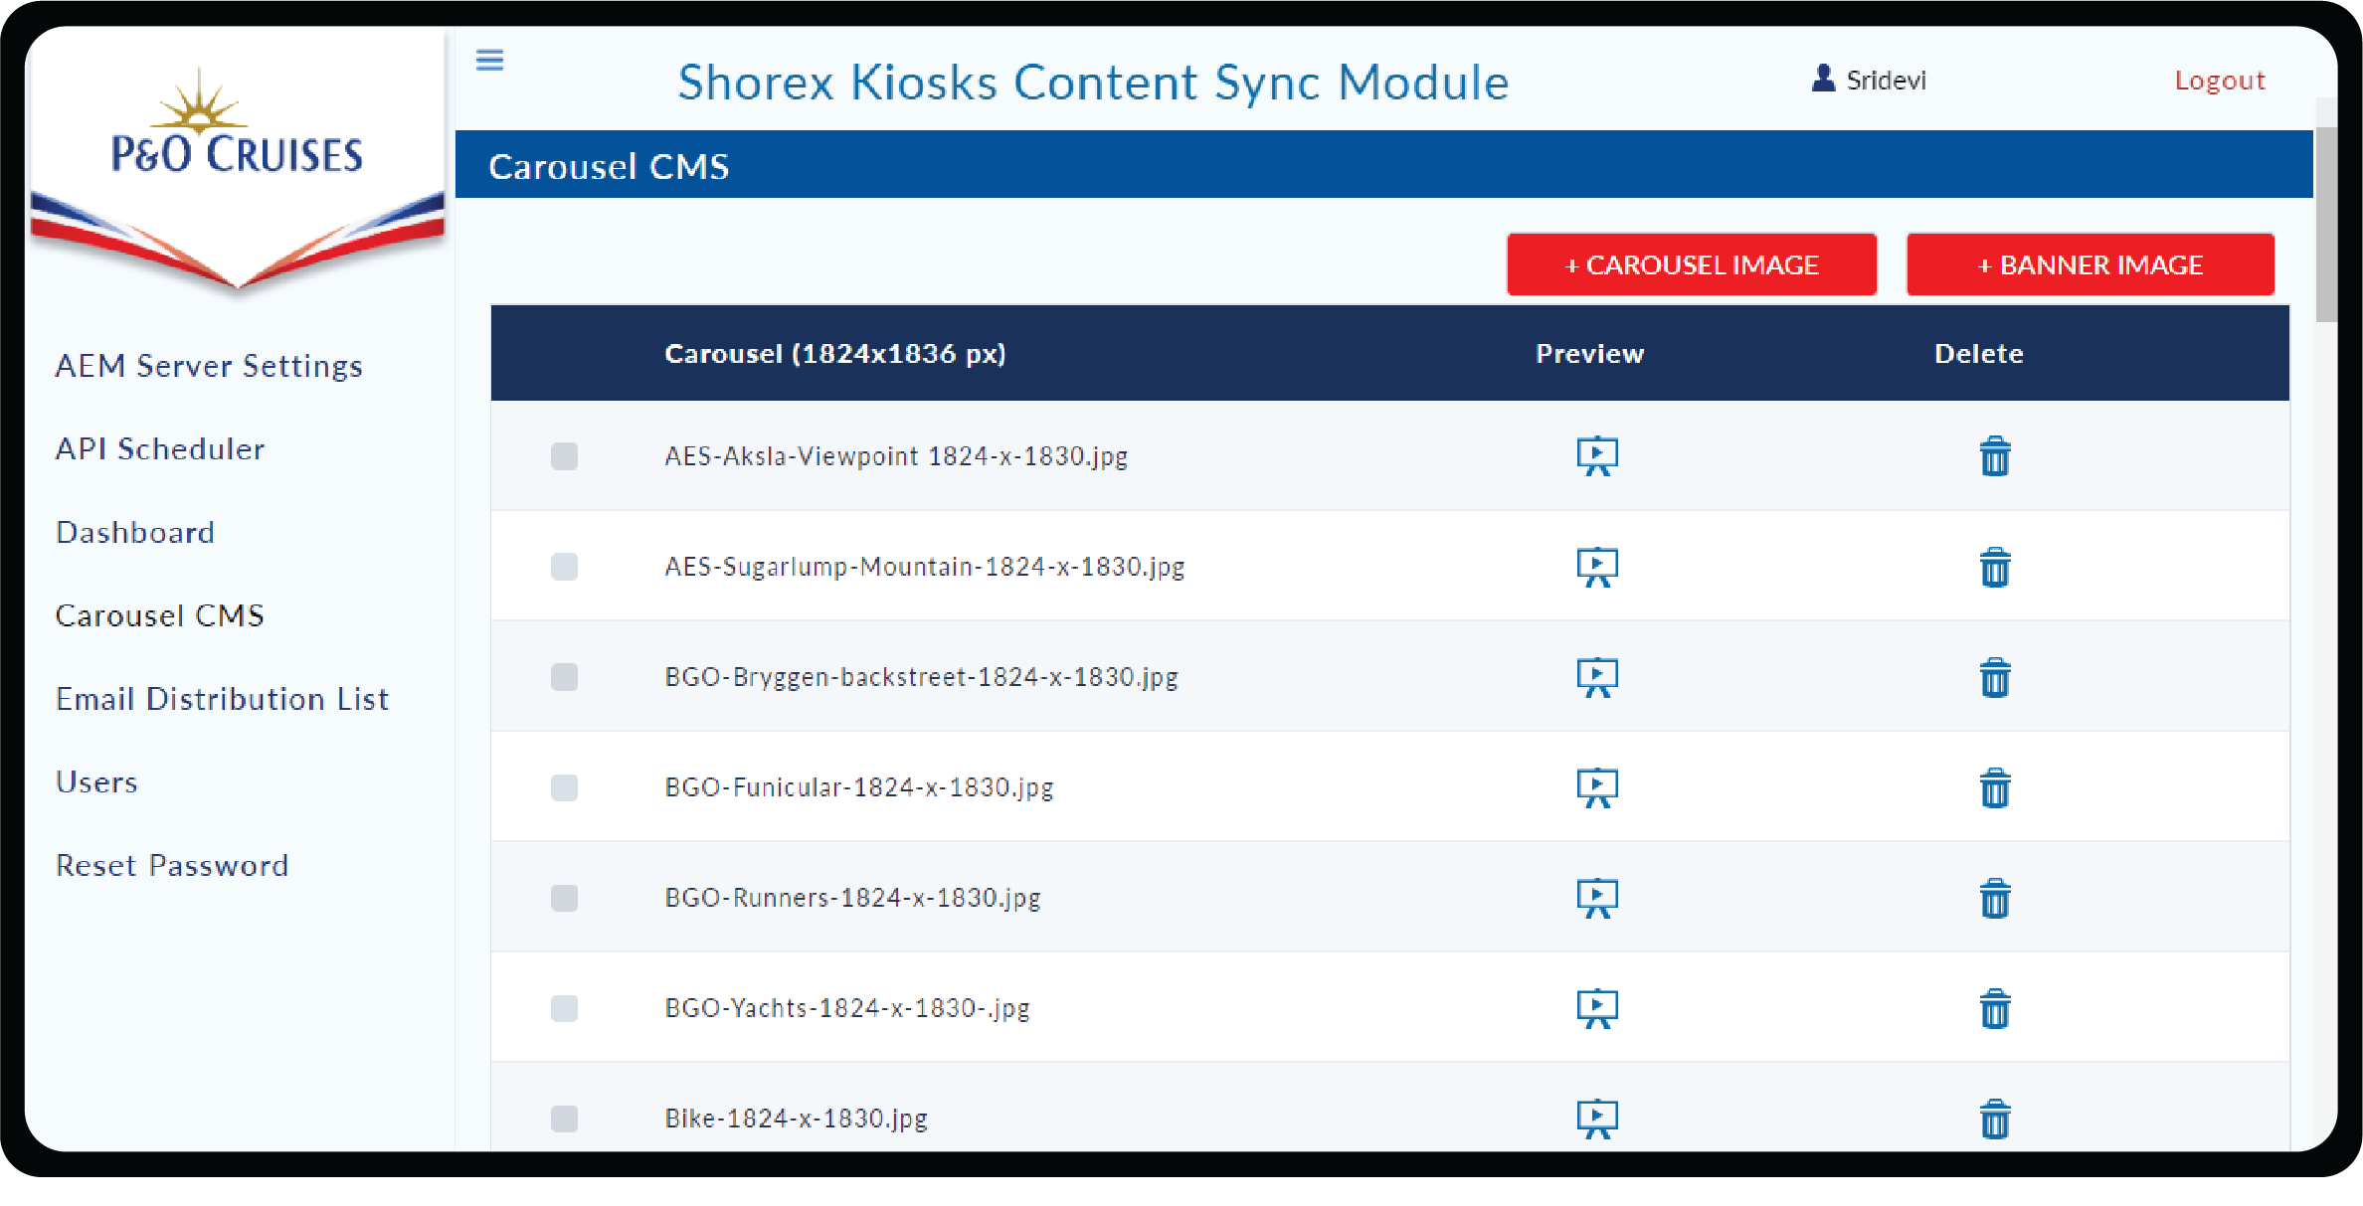

**Preview icon** is used to preview the uploaded image and can be closed by clicking outside the image after viewing.

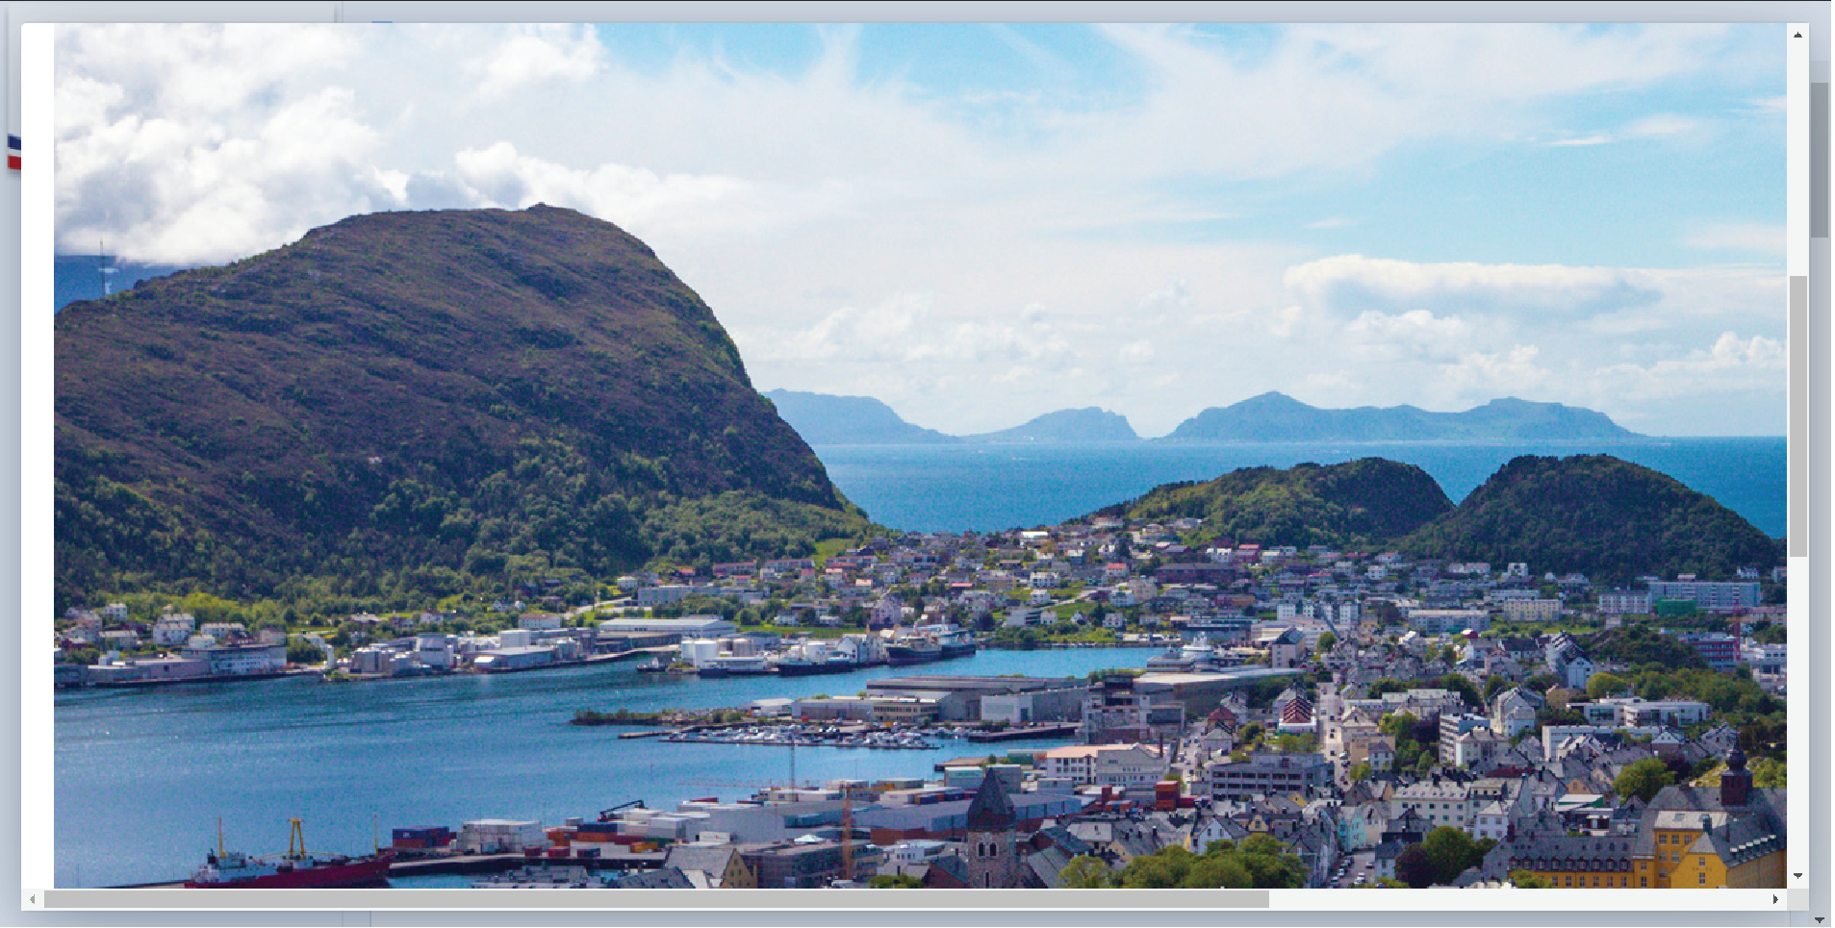

You can perform the following actions on this page.

**Add Carousel Images:** You can click on **+CAROUSEL IMAGE** to upload Carousel Images to Content Sync CMS by clicking **Upload File** button or **drag and drop method** and click on **Submit** button.

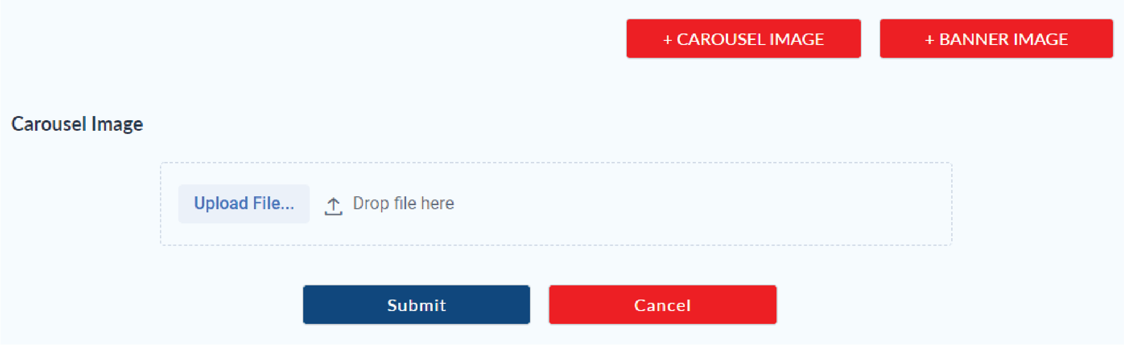

**Save Carousel Images:** You can rearrange the Carousel image by drag and drop. Click on **Save** button for Import (in Control Centre).

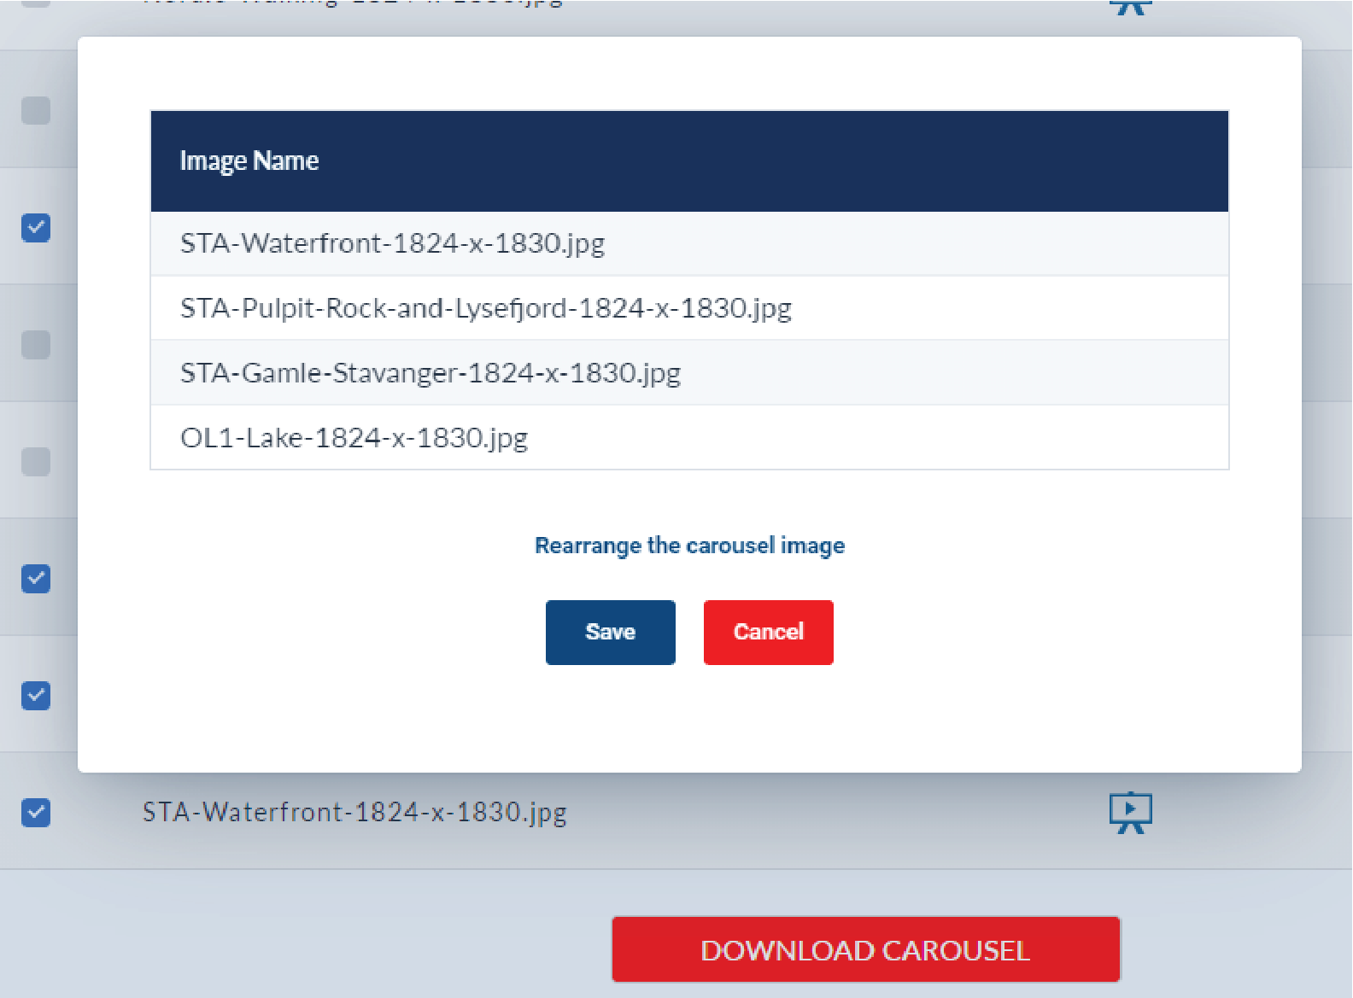

**Download Carousel Images:** After clicking on **Save** button a confirmation box will pop-up whether to download the selected file or not. Click on **Download** button to download the image bundle or cancel by clicking on **Cancel** button.

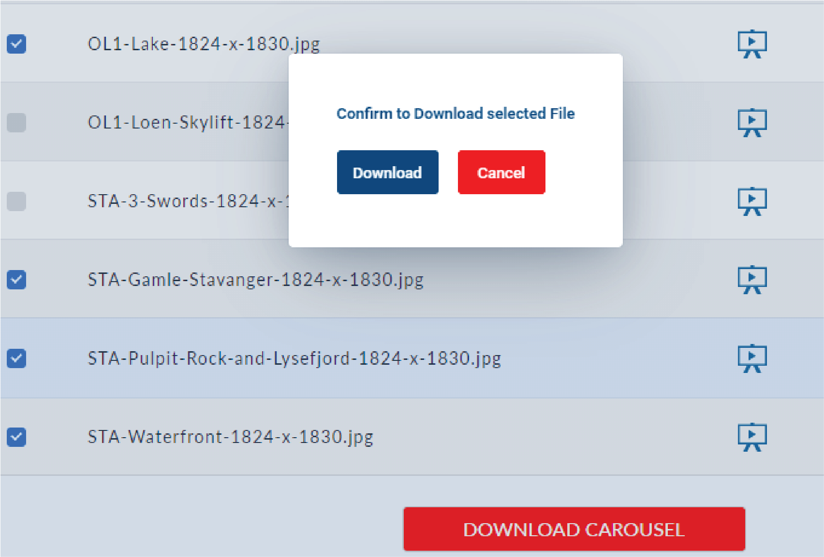

**Add Banner Images:** You can click **+BANNER IMAGE** to upload Banner Images to Content Sync CMS by clicking on **Upload File** button or **drag and drop method**.

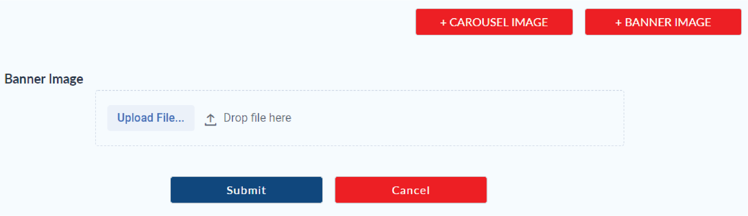

**Download Banner Images:** You can download Banner Images for Import (in Control Centre) by clicking on **Download** button.

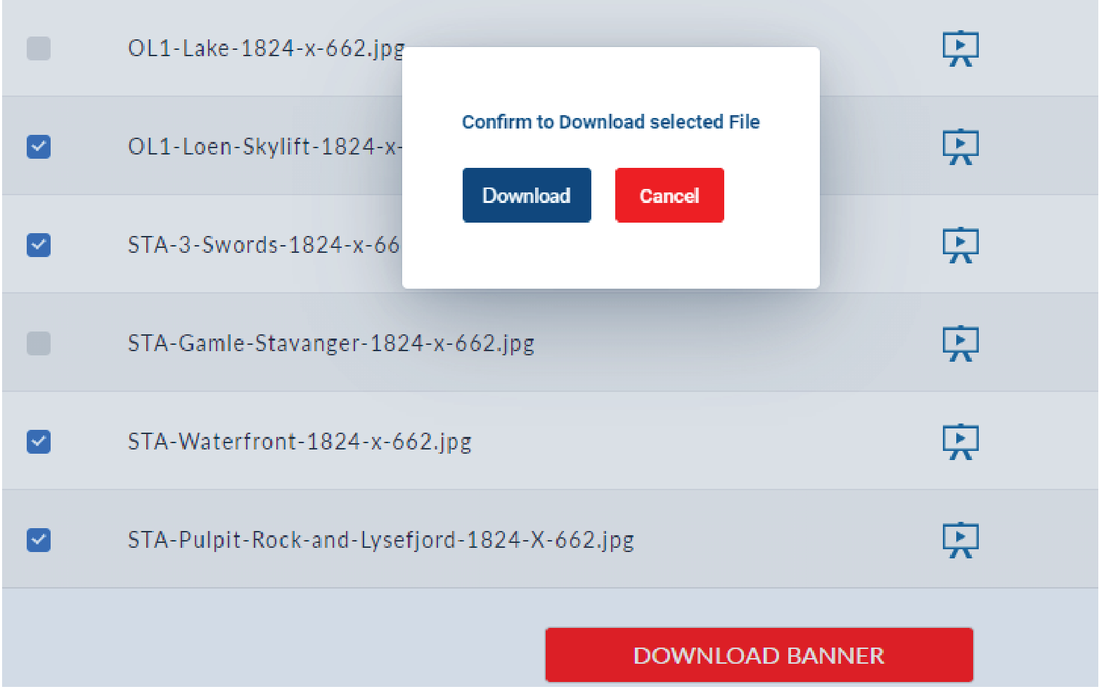

# 6. Email Distribution List

You can use the email distribution list to configure the email Ids to which the notifications have to be sent to.

You can perform the following actions

**Add :** Add a new email to the distribution list by clicking the **+NEW EMAIL** Button and **Submit** upon filling the details.

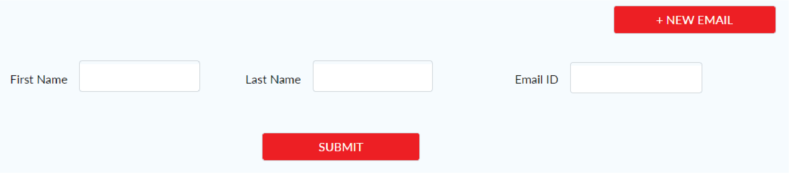

**Delete:** Delete an email from the distribution list by clicking the **Delete** Icon next to the email.

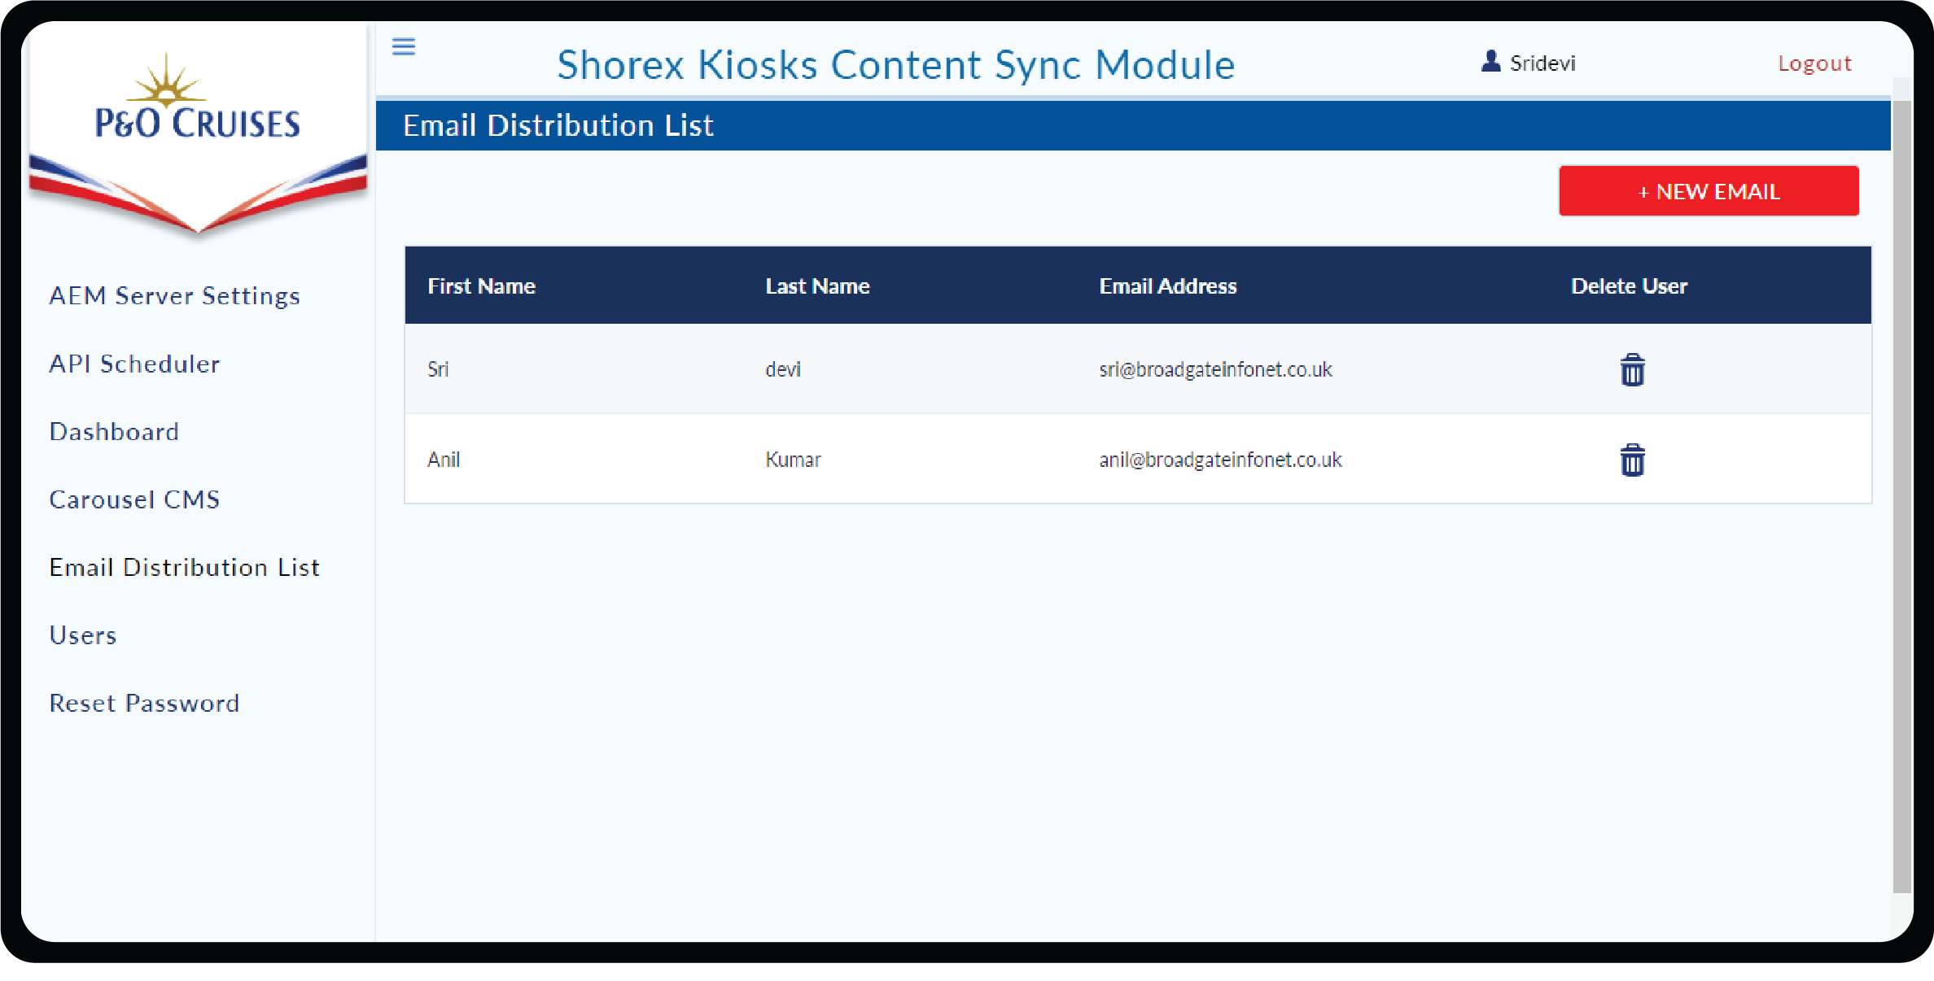

# 7. Users

You can perform the following actions

**Add:** Add a new user to the application click **+NEW USER** Button and **Submit** upon filling the details.

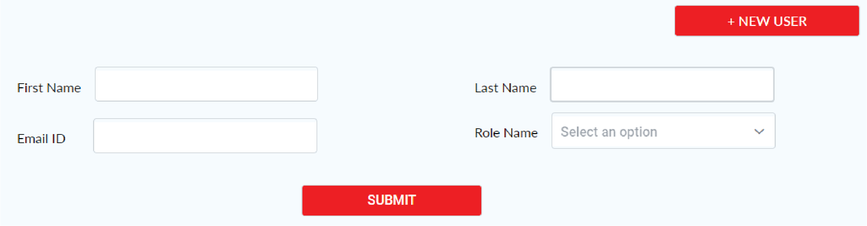

**Edit:** Edit an existing user by clicking the **Edit** Icon to change your First and Last name only.

**Delete:** Delete an user from the distribution list by clicking the **Delete** Icon.

Logged in Admin cannot be able to delete themselves and also cannot Edit/Delete SuperAdmin user.

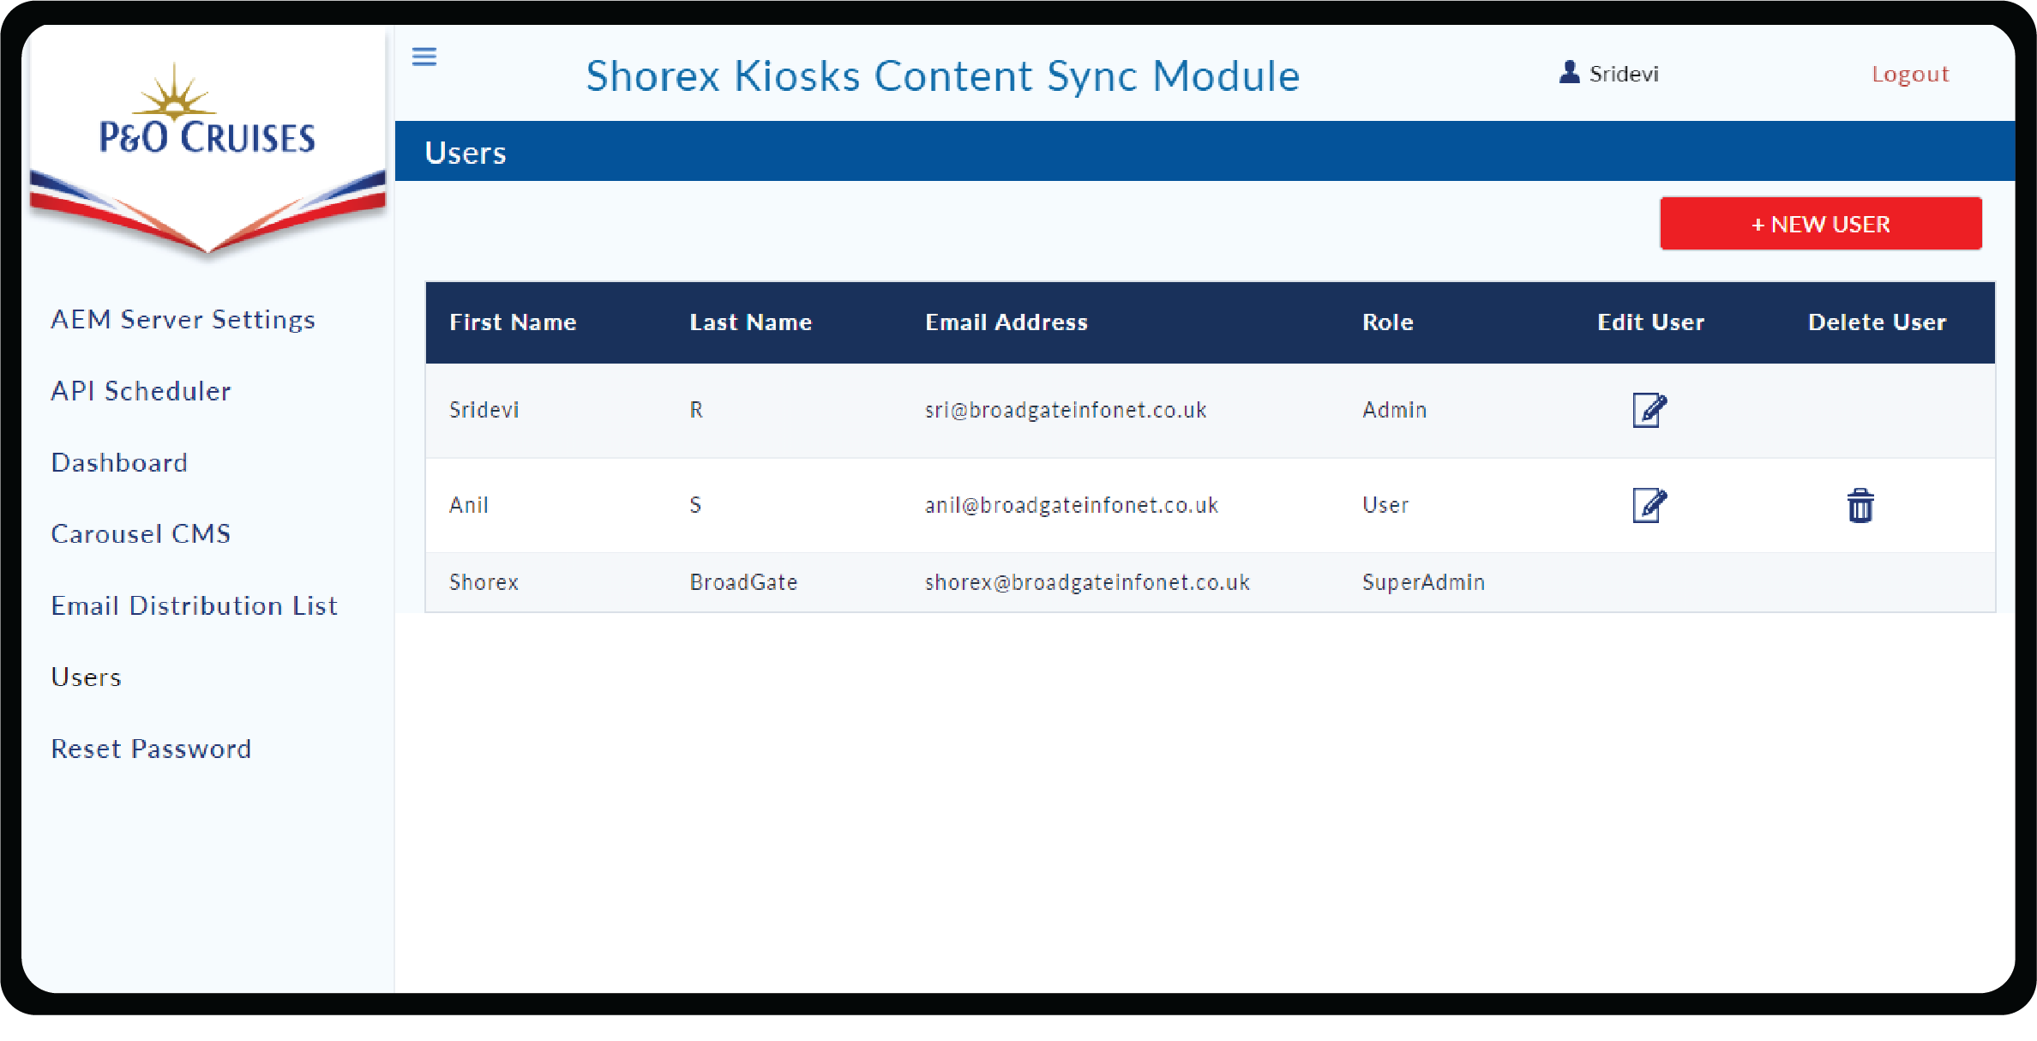

**8. Reset Password**

Reset Password, facilitates the logged on user to change the password.

In order to reset, you need to enter Current Password, New Password and Confirm Password and click **Reset** button. You can login with new password during the next login.

